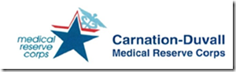

MRC: Meeting January 15
When: January 15, 2020 6:45-8:45 p.m.
Where: Downtown Duvall Fire Station, corner of 1st and Stella, meeting room
Agenda:
Review of Incident Command System and HIPPA policies
Splinting practice
Additional Information:
Is your badge expiring? Have you filled out an emergency worker application and is your information still up to date on it? If you need a new badge or any paperwork updating, talk to Lisa (lisabrouwer@frontier.com). I’m still trying to get everyone’s information updated.
Those who have indicated a Level 2 involvement (being kept up to date on meetings and activities vs. level 3- notify only in an actual deployment) should expect an Emerging Event text communication test in the near future. If you are not currently and would like to be included in this level 2 group you can give Lisa at the above email your number for receiving texts.
Be aware of the inclement weather forecast for next week. If we see snowmaggedon levels again, the test could become the real thing and any meeting cancellation will be communicated if necessary.

